British Championships – Golden Valley
GU30 7LP

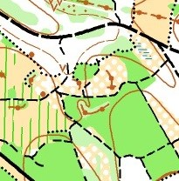 Iron Hill
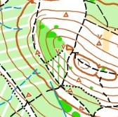 Green Hill
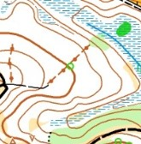 Golden Valley
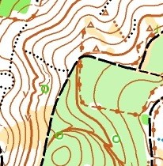 The Leithe
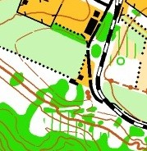 Relay Arena ?
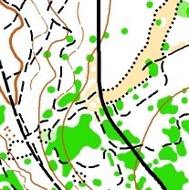 Stanley Common

Tove Alexanderson middle training
https://www.youtube.com/watch?v=Q_yitYOdK0M

